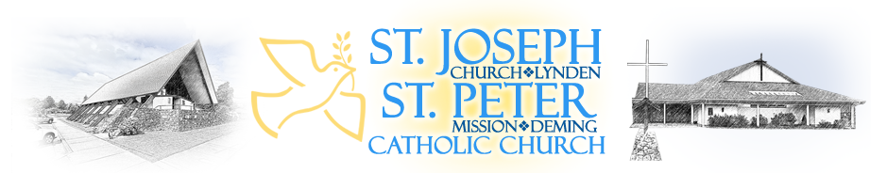
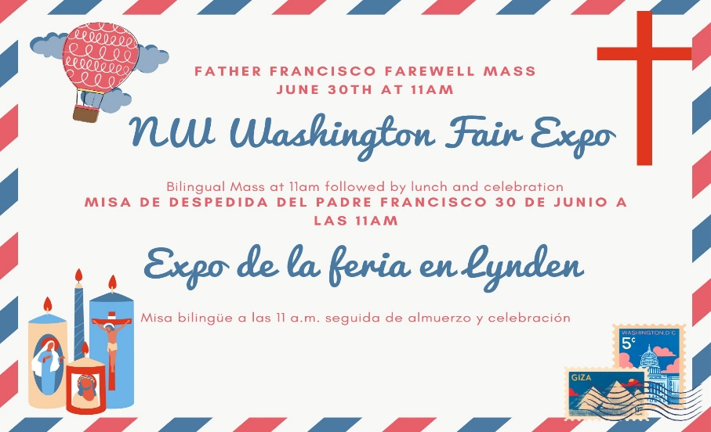
We will be celebrating Father Francisco’s departure. We are asking parishioners with last names a-l to bring desserts and m-z to bring a side salad or snack. The church will be providing the main courses. We are also looking for volunteers to play music or dance after the Mass, if you are interested, please let the front office know. The 8:30am Mass and the 11am Mass will be moved to the expo center that day, so please plan accordingly. Estaremos celebrando la partida del Padre Francisco. Estamos pidiendo a los feligreses con apellidos a-l que traigan postres y m-z que traigan una ensalada o un refrigerio. La iglesia proporcionará los platos principales. También estamos buscando voluntarios para tocar música o bailar después de la Misa, si está interesado, comuníqueselo a la oficina principal.

RETREATS AND SPECIAL EVENTS:
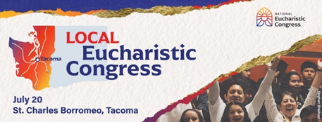
The Archdiocese of Seattle is hosting a local version of the National Eucharistic Congress! This summer, Catholics will travel from every corner of our archdiocese to experience the real presence of Jesus Christ. This local Congress includes all of the activities that are taking place at the national event: inspirational talks, adoration, praise & worship music, prayer, a Eucharistic procession and Mass. The Young Adult Group will be arranging a trip, if you want to attend get in contact with the front office or missionaries. ¡La Arquidiócesis de Seattle está organizando una versión local del Congreso Eucarístico Nacional! Este verano, los católicos viajarán desde todos los rincones de nuestra arquidiócesis para experimentar la presencia real de Jesucristo. Este Congreso local incluye todas las actividades que se llevan a cabo en el evento nacional: charlas inspiradoras, adoración, música de alabanza y adoración, oración, procesión eucarística y misa. El Grupo de Jóvenes Adultos estará organizando un viaje, si desea asistir comuníquese con la oficina principal o con los misioneros.

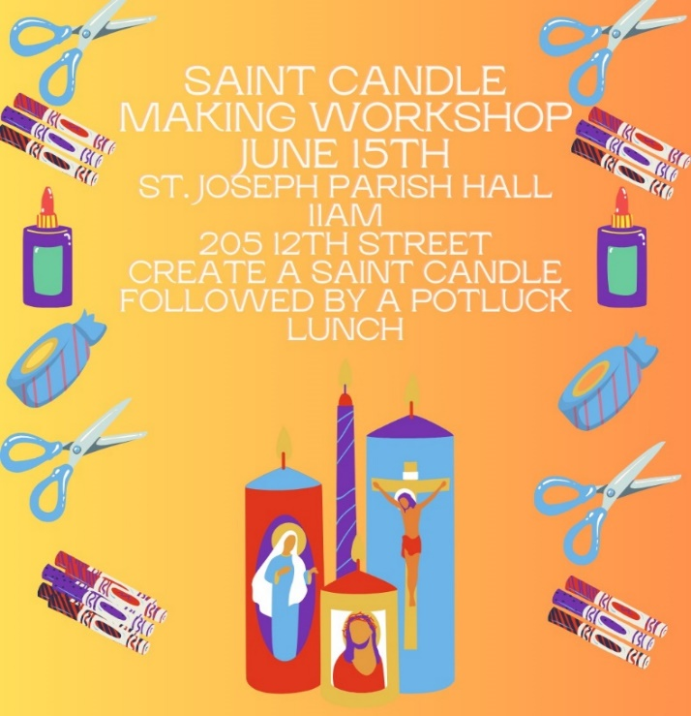
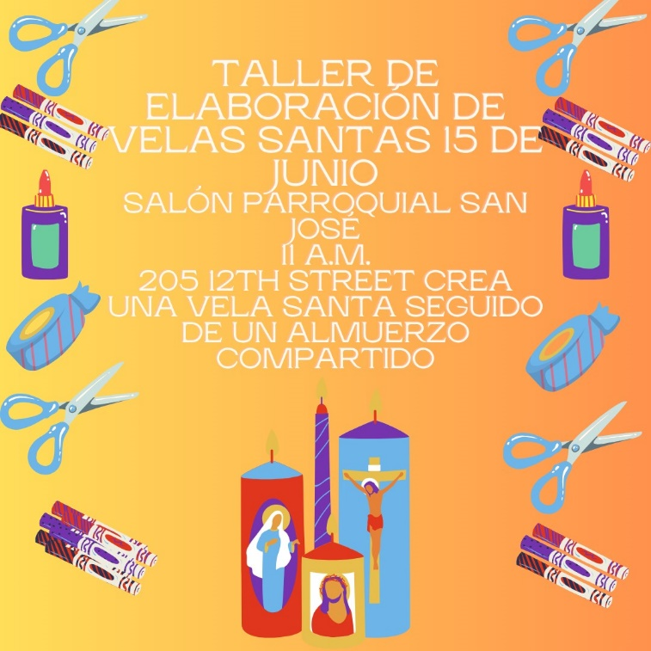

Saint Candle Making Workshop: We will be making saint candles, please RSVP to the front office so we can ensure that we have enough candles. We are also in need of some saint cards, which can be donated to the front office. Estaremos haciendo velas santas, confirme su asistencia a la oficina principal para que podamos asegurarnos de que tengamos suficientes velas. También necesitamos tarjetas de santos, que se pueden donar a la oficina principal.
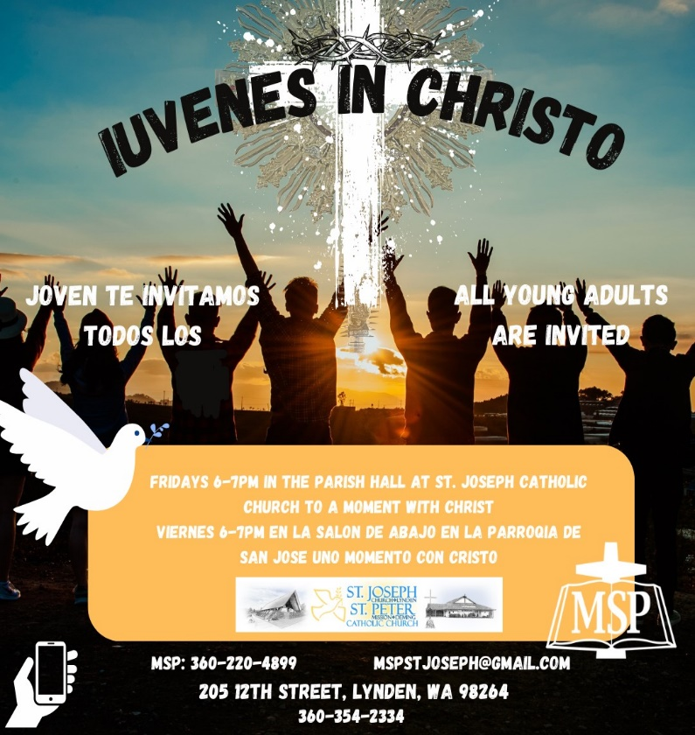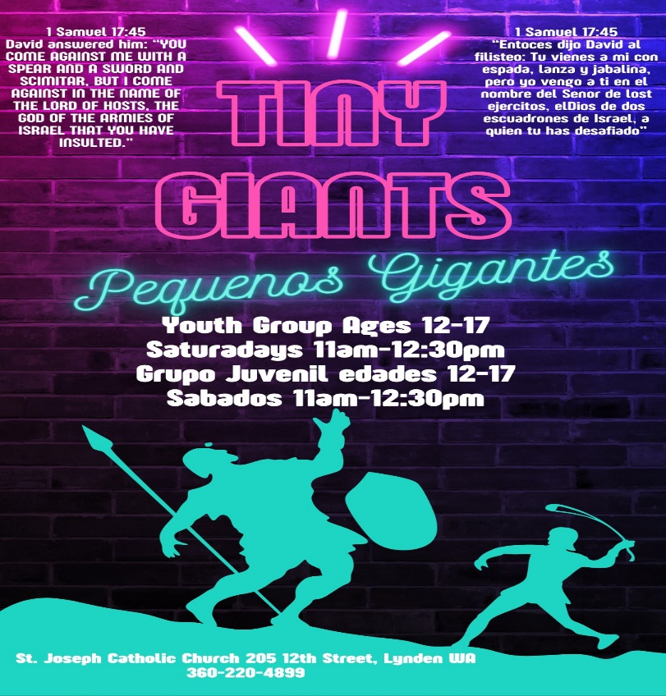
Every Thursday @St. Joseph
Adoration 9:30—11:00 am
Patriotic Rosary 11:30 am
Every Friday-@St. Joseph
Divine Mercy Chaplet 3:00 pm
Led by Peggy Chase
Volunteer Opportunities:
Prepares news:
Thanks to our Generous Parish we were able to serve 30 families at our May 3rd Friday Diaper Giveaway and Kids Boutique.
We are in need of more bilingual (Spanish/English) Volunteers. To get involved to whatever degree YOU choose, with this awesome ministry please call Pam Ames at 360)510-2334.
Shop the PREPARES Wishlist using the QR code. We are in need of Size 6 diapers, wipes, boys clothes NB-5t and new or gently used children’s shoes. We also are in need of grocery bags, that we put the diapers in. Donations can be brought to the front office or online donations can be made. We are so thankful for our community’s generous support. We currently serve 128 families in Whatcom County!

English Choir Welcomes All: We want YOU to join St. Joseph English Choir. Practice every Wednesday from 7-8pm. All are welcome. Please call Leona Foster at 360-220-9757.
Sacristans and Ushers needed for English Masses at St. Joseph: We are in need of more Sacristans and Ushers for the 5pm and 11am masses. Are you interested please contact the front office.
St. Joseph Religious Education Chatechists and Volunteers Needed: We are in need of volunteers for the 2024-2025 religious education year. Each year we have at least 150-175 students and adults participate in religious education classes. We are in need of volunteers to ensure that our students can grow in their faith. We are in need of lead catechists and then assistants to help with the classes. Assistants are open to any high school student who has completed their Confirmation, and it is a great way to grow the faith. We will provide training and support to all catechists. If you are interested in volunteering, please contact the front office or Marisol. Estamos buscando voluntarios de habla hispana para el programa RICA para niños y el programa RICA para adultos en español, si está interesado por favor comuníquese con Marisol. Registrations will open June 18th for religious education.
Class | Catechist | Assistant | Assistant
PreK (Sunday Mornings) |  | Jake Lautenbach
First Year First Communion 1-2nd (Wednesday) |  | Pam Ames
First Year First Communion 3rd-6th (Wednesday)
Second Year First Communion 1-2nd (Wednesday) | Mirna Zavala
Second Year First Communion 3rd-6th (Wednesday) | Hugo Mendoza | Miguel Lux
Childrens RCIA (Spanish) (Sundays) | Brenda Panguia | Mary Castro-Ortiz
Confirmation (Thursdays) | Fredy Perez/ Olivia Phillips | Leena Charelton
English RCIA | Leona Foster
Spanish RCIA (Sundays)
Youth Group Highschool (Sundays) | Veronica Charelton
Youth Group Post First Communion (Sundays)
Family Faith Formation (English) | Pam Ames
Family Faith Formation (Spanish) | Missionaries/CERS | Missionaries/CERS | Missionaries/CERS
Young Adult Group (Friday) | Olivia Phillips/ Miguel Lux/Missionaries
Social Action: Social action is available for all or consider helping our social action programs below! ¡La acción social está disponible para todos o considera ayudar a nuestros programas de acción social a continuación!
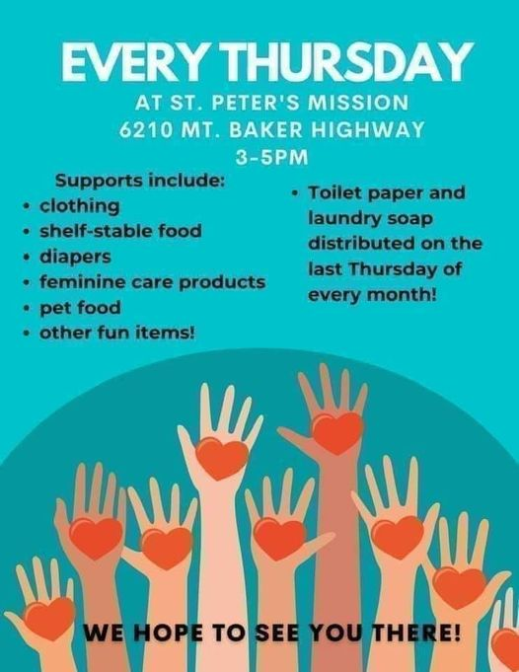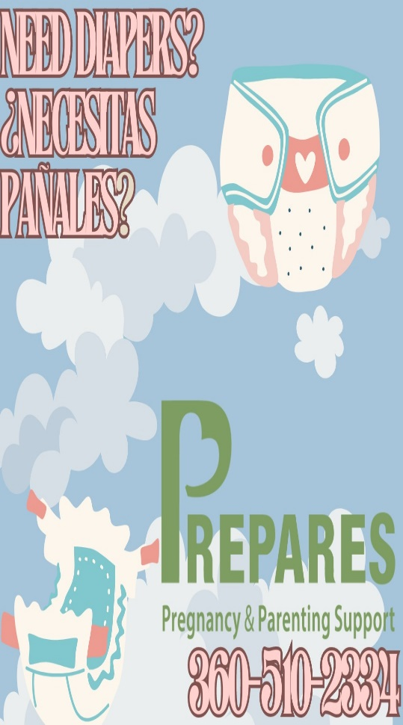
Registration Update: We are in the process of updating our parishioner database to Parishstaq and are excited to be launching a new email and text message feature. We are asking ALL parishioners to ensure their information is updated, and to reregister below. Please fill out the form below and return it to the collection basket or the front office. Actualización de registro: Estamos en el proceso de actualizar nuestra base de datos de feligreses a Parishstaq y estamos entusiasmados de lanzar una nueva función de correo electrónico y mensajes de texto. Les pedimos a los feligreses que se aseguren de que su información esté actualizada y que se vuelvan a registrar a continuación. Complete el formulario a continuación y devuélvalo a la canasta de recolección o a la oficina principal.
Registration Location/ Ubicación de registro: St. Joseph/San Jose_ St. Peter_
Mailing Address/Direccion de envio :____________________________________________________________________________

___________________________________________________________________________________________________________
City/ciudad State/estado Zip Code/código postal

Phone Number/Telefono #1: _________________________ Phone Number/Telefono #2_______________________

Email 1: ______________________________________ Email 2:_________________________________________

 | First and Last Name | Date of Birth
1. | Head of Household
2. | Spouse
3. | Children living in the household
4.
5.
6.*
Would you like to sign up for Parish Wide Emails? ¿Le gustaría registrarse para recibir correos electrónicos de toda la parroquia? Yes__ No__
Would you like to receive information about volunteer opportunities in the Church? ¿Le gustaría recibir información sobre oportunidades de voluntariado en la Iglesia? Yes__ N0__
Sacrificial Envelopes: A monthly subscription for weekly tithing and special collections. Please indicate whether you would like to receive them or not. : Una suscripción mensual para diezmos semanales y colectas especiales. Por favor indica si deseas recibirlos o no Yes__ No __
Preferred Language/ Preferred Language:
__English
__Espanol
Other/Otro:__________________________

