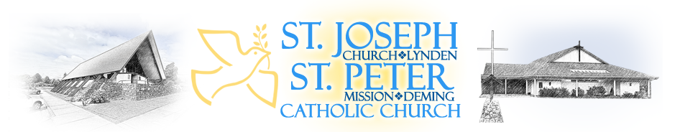
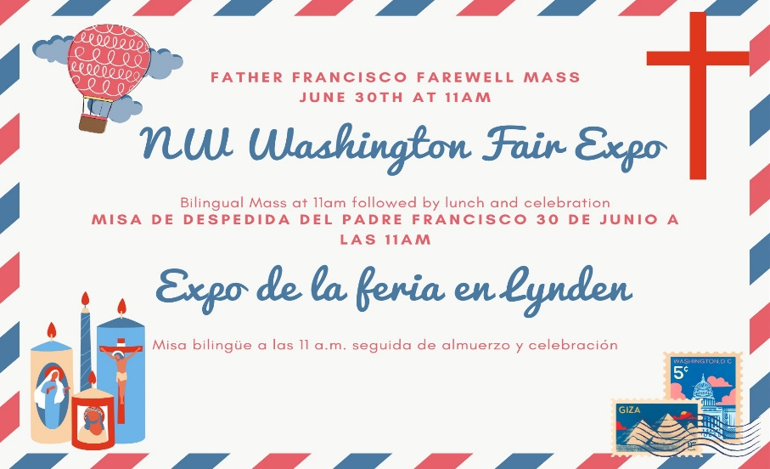
We will be celebrating Father Francisco’s departure. We are asking parishoners with last names a-l to bring desserts and m-z to bring a side salad or snack. The church will be providing the main courses We are also looking for volunteers to play music or dance after the Mass, if you are interested, please let the front office know. Estaremos celebrando la partida del Padre Francisco. Estamos pidiendo a los feligreses con apellidos a-l que traigan postres y m-z que traigan una ensalada o un refrigerio. La iglesia proporcionará los platos principales. También estamos buscando voluntarios para tocar música o bailar después de la Misa, si está interesado, comuníqueselo a la oficina principal.
Annual Appeal:
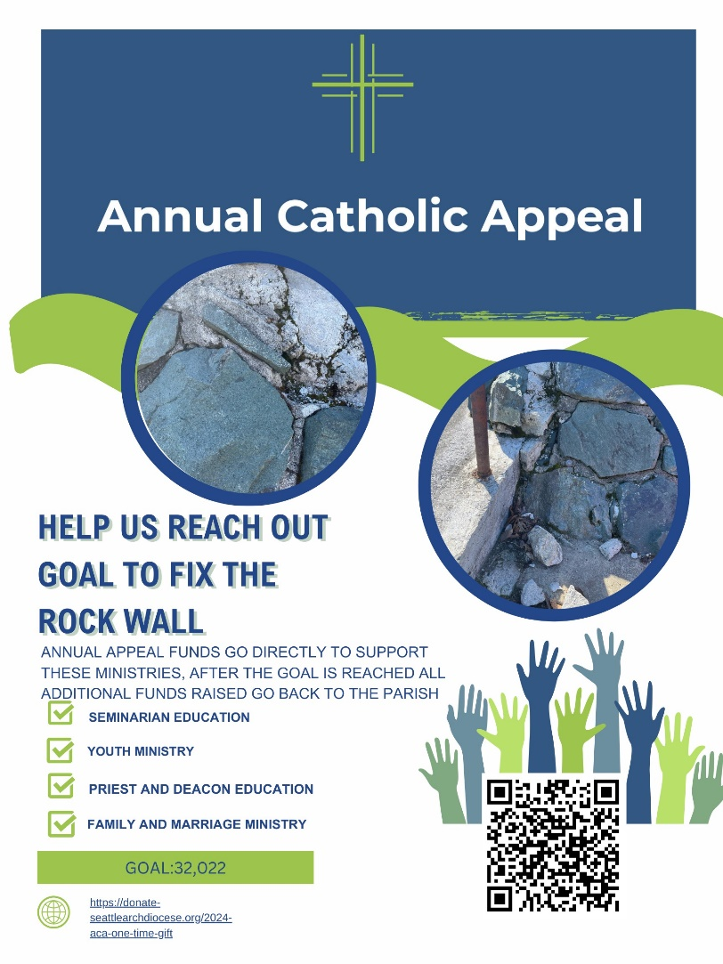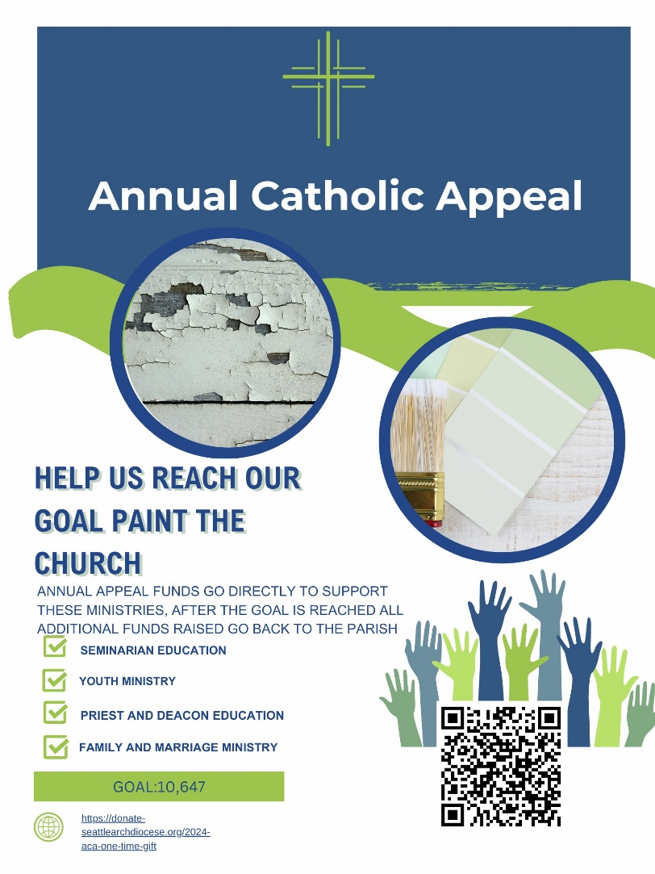

Partners in the Gospel News:
A Note from Fr. Moore
Dear Whatcom County Parishioners,
At this point, you all should have heard the new priest assignments for the county starting on July 01, including that I will be continuing on as pastor of our county-wide family. Two notes on that:
1. I am very excited to get to know and to work with everyone in the county! However, with Partners in the Gospel we want to begin and walk the journey together, meaning that it is important we follow the timeline that the Archdiocese has given us. From now until July 01, your current pastor is still your pastor, and I hope you will continue to look to him for pastoral care and guidance.
2. Even though our journey together does not formally start until July 01, there are quite a few decisions that I have to make behind the scenes to prepare for a new slate of priests. I want to be as transparent as possible as I do these preparations, so you can follow along with – and comment on – these decisions at https://www.whatcomcatholic.org/updates.
Blessings!
-Fr. Moore
“Una nota del P. moore
Estimados feligreses del condado de Whatcom:
En este punto, todos deberían haber escuchado las nuevas asignaciones de sacerdotes para el condado a partir del 1 de julio, incluido que continuaré como pastor de nuestra familia en todo el condado. Dos notas sobre eso:
1. ¡Estoy muy emocionado de conocer y trabajar con todos en el condado! Sin embargo, con Compañeros en el Evangelio queremos comenzar y recorrer el camino juntos, lo que significa que es importante que sigamos el cronograma que nos ha dado la Arquidiócesis. Desde ahora hasta el 1 de julio, su pastor actual sigue siendo su pastor y espero que continúe recurriendo a él en busca de atención y orientación pastoral.
2. Aunque nuestro viaje juntos no comienza formalmente hasta el 1 de julio, hay bastantes decisiones que tengo que tomar entre bastidores para prepararme para una nueva lista de sacerdotes. Quiero ser lo más transparente posible mientras hago estos preparativos, para que puedan seguir y comentar estas decisiones en https://www.whatcomcatholic.org/updates.
¡Bendiciones!
-P. moore
RETREATS AND SPECIAL EVENTS:
Prolife: Calling all Catholic Men—join the prolife movement to learn about the important role that men play. We will be having a discussion about the importance of Fathers in the role of the lives of children. May 6th at 7pm in the Lions Den.
Volunteer for Coffee Hour: Interested at hosting Coffee Hour at St Joes? Reach out to Marilyn, Charity or Elizabeth or find the sign up sheet at the back of the Church! ¿Interesado en organizar la Hora del Café en St Joes? ¡Comuníquese con Marilyn, Charity o Elizabeth o busque la hoja de iscripción en la parte trasera de la Iglesia!
Local Eucharistic Confrence
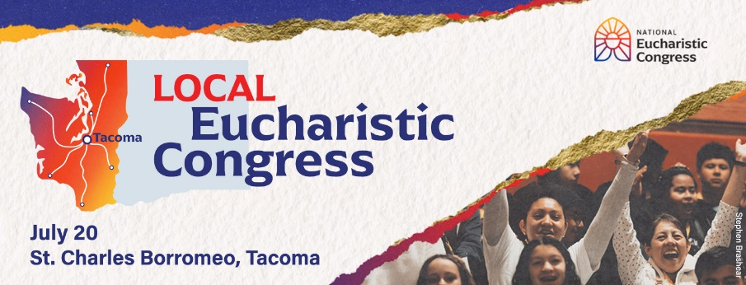
The Archdiocese of Seattle is hosting a local version of the National Eucharistic Congress! This summer, Catholics will travel from every corner of our archdiocese to experience the real presence of Jesus Christ. This local Congress includes all of the activities that are taking place at the national event: inspirational talks, adoration, praise & worship music, prayer, a Eucharistic procession and Mass. ¡La Arquidiócesis de Seattle está organizando una versión local del Congreso Eucarístico Nacional! Este verano, los católicos viajarán desde todos los rincones de nuestra arquidiócesis para experimentar la presencia real de Jesucristo. Este Congreso local incluye todas las actividades que se llevan a cabo en el evento nacional: charlas inspiradoras, adoración, música de alabanza y adoración, oración, procesión eucarística y misa.
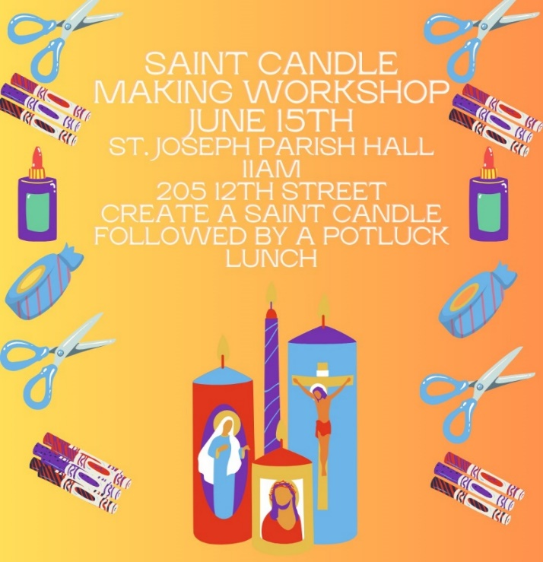
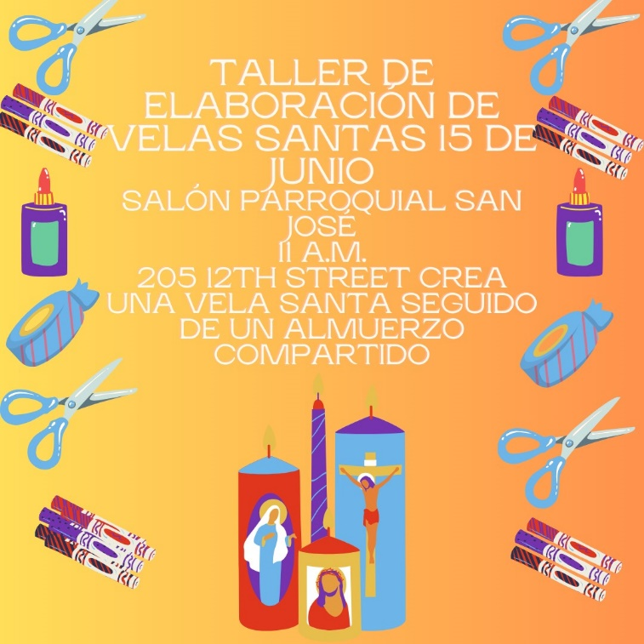

Saint candle making workshop: We will be making saint candles, please RSVP to the front office so we can ensure that we have enough candles. We are also in need of any saint cards, which can be donated to the front office. Estaremos haciendo velas santas, confirme su asistencia a la oficina principal para que podamos asegurarnos de que tengamos suficientes velas. También necesitamos tarjetas de santos, que se pueden donar a la oficina principal.
Prolife Retreat: We are so excited to open registration for the Womb to Tomb prolife retreat hosted by the St. Joseph Catholic Church prolife ministry. We will be having speakers from 3W, PREPARES, Project Rachel, Washington State Catholic Conference, Engedi Refuge, and Whatcom County Pregnancy Clinic. The goal of the retreat is to unify the prolife movement to serve women and their families. We hope participants will feel engaged and hopeful for the future of the prolife movement in Washington state. This retreat will start at 9am and end at 5pm with Mass. We will be providing lunch. There is a suggested donation of $35, which will help cover the costs of lunch and other supplies for the retreat. All other funds raised will be given to the St. Joseph PREPARES ministry, which helps families with diapers, wipes, and other basic necessities. Thank you for registering and we can't wait to see you there.
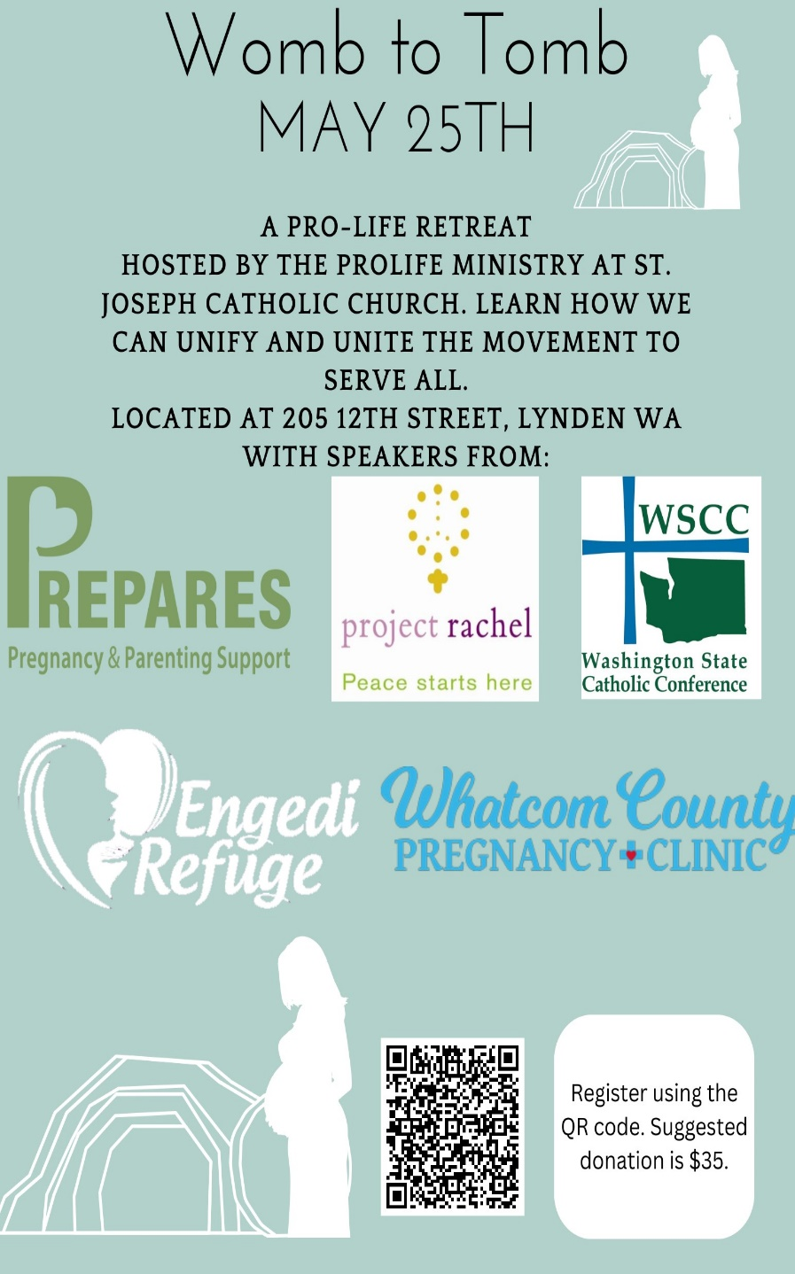
Registration Form for Prolife Retreat: Please cut out and return to the office or visit our website to register. Donation can be made online or handed in with this sheet.
Name:____________________________
Phone Number:________________________
Email:___________________________________
Address:_______________________________
________________________________________
Dietary Restrictions:________________________
Additional Comments or Questions:_____________________________________________________________________________________________________________________________________________________________________________________________________

Re-accruing Weekly/Monthly
Join the St Joseph Young Adult Group
Calling all 18–30-year-old Catholics, join young adult Catholics in the Parish Hall every Friday from 6-7 pm. This group includes. Bible study, games, fun activities nights and lots of adoration to the Lord!
Questions? Contact Miguel Lux (360)393-9836 or Olivia Phillips Llamando a todos los católicos de 18 a 30 años, únanse a los jóvenes adultos católicos en el Salón Parroquial todos los viernes de 6 a 7 p.m. Este grupo incluye. ¡Noches de estudio bíblico, juegos, actividades divertidas y mucha adoración al Señor!
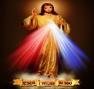
Meetings:
Every Thursday @St. Joseph
Adoration 9:30—11:00 am
Patriotic Rosary 11:30 am
Led by Peggy Chase
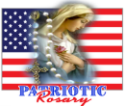
Every Friday-@St. Joseph
Divine Mercy Chaplet 3:00 pm
Every Thursday @St. Joseph
Adoration 9:30—11:00 am
Patriotic Rosary 11:30 am
Every Friday-@St. Joseph
Divine Mercy Chaplet 3:00 pm
Led by Peggy Chase
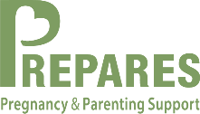
PREPARES NEWS
Thanks to our Generous Parish we were able to serve 50 families at our April 3rd Friday Diaper GiveAway and Kids Boutique. Then welcomed 6 others for PREPARES Perks on Tuesday with Snacks, Parenting Discussion and Kids Playtime.
We are in need of more bilingual (Spanish/English) Volunteers. To get involved to whatever degree YOU choose, with this awesome ministry please call Pam Ames at 360)510-2334.
Bless You All!
Youth Group: Let’s Engage our Youth:
St. Peter: After Mass 5/19 Get in contact with Amanda, Brooke or Bailey!
St. Joseph:, 4/28, 5/5, 5/19 at 12:30pm in the Parish Hall. Call or Text Veronica at: 509-280-6123
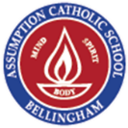
Catholic Homeschool Group: Veronica Charelton is hoping to start a monthly/ homeschool group for Catholic youth in Whatcom county, if you are intereted please contact the front office or give Veronica Charelton a call at: 509-280-6123
Employment Opportunity at ACS
Assumption Catholic School is hiring for a first-grade teacher to begin in the 2024-2025 school year. The applicant should have a Washington State teaching certificate and be a practicing Catholic. More information about the post can be found on the school's website (assumption.school) under Employment Opportunities. Any questions can be emailed directly to Principal Dan Anderson at danderson@assumption.school.
Volunteer Opportunities:
English Choir Welcomes All: We want YOU to join St. Joseph English Choir. Practice every Wednesday from 7-8pm. All are welcome. Please call Leona Foster at 360-220-9757.
Sacristans and Ushers needed for English Masses at St. Joseph: We are in need of more Sacristans and Ushers for the 5pm and 11am masses. Are you interested please contact the front office.
Money Counters needed: Come join a lovely group of people on Mondays 9-11am to count money, training will be provided. We are in need of a couple of more lovely faces. If interested, please reach out to the front office. Training will be provided and commitment is once a month.
St. Joseph Religious Education Chatechists and Volunteers Needed: We are in need of volunteers for the 2024-2025 religious education year. Each year we have at least 150-175 students and adults participate in religious education classes. We are in need of volunteers to ensure that our students can grow in their faith. We are in need of lead chatechists and then assistants to help with the classes. Assistants are open to any highschool student who has completed their Confirmation, and it is a great way to grow the faith. We will provide training and support to all chatechists. If you are interested in volunteering please contact the front office or Marisol. Estamos buscando voluntarios de habla hispana para el programa RICA para niños y el programa RICA para adultos en español, si está interesado por favor comuníquese con Marisol. Registrations will open June 18th for religious education.
Class | Chatechist | Assistant | Assistant
PreK (Sunday Mornings)
First Year First Communion 1-2nd (Wednesday) |  | Pam Ames
First Year First Communion 3rd-6th (Wednesday)
Second Year First Communion 1-2nd (Wednesday)
Second Year First Communion 3rd-6th (Wednesday)
Childrens RCIA (Spanish) (Sundays)
Confirmation (Thursdays) | Fredy Perez/ Olivia Phillips | Leena Charelton
English RCIA | Leona Foster
Spanish RCIA (Sundays)
Youth Group Highschool (Sundays) | Veronica Charelton
Youth Group Post First Communion (Sundays)
Family Faith Formation (English) | Pam Ames
Family Faith Formation (Spanish) | Missionaries/CERS | Missionaries/CERS | Missionaries/CERS
Young Adult Group (Friday) | Olivia Phillips/ Miguel Lux/Missionaries

